COMMODITY (ECU/BASE #): _________________________________________________

PROGRAM / MODEL YEAR: _________________________________________________

PROGRAM MILESTONE: _________________________________________________

REVIEW DATE: _________________________________________________

D&R ENGINEER (with email address and Phone number):_________________________________________________

SUPPLIER CONTACT (with email address and Phone number):_________________________________________________

SOFTWARE ENGINEER / IVS COMMODITY ENGINEER (w/email address and Phone number):____________________________________

Meeting Purpose and Participants
Meeting Purpose | Participants
Meeting Purpose | Ford | Supplier
Review supplier In-Vehicle Software capability using various criteria:  - Supplier manufacturing process  - Ford manufacturing process  - Part Number Structure  - Ford IVS capability / training  - Team assumptions | Software D&R Engineer | Software Engineer
 | Hardware D&R Engineer | Software Supervisor
 | Software Specialist | Hardware Engineer
 | Meeting Duration = 2 Hours
Documents Needed at Meeting
Refer to IVS Section in the Software Project Tracking Checklist

 Table of Contents
- Questions
- In-Vehicle Software Release & Module Flash 2
SECTION A (Pre-ISO & ISO 14229 module)………………………………………………………………………………………………………....3
1 Ford Part Numbers…………………………………………………………………………………………………………………....3
2 Configuration…………………………………………………………………………………………………………………………5
3 Compatibility…………………………………………………………………………………………………………………………6
4 Identify Responsible Parties………………………………………………………………………………………………………….6
5 NetCom Test / Validation…………………………………………………………………………………………………………….8
6 FCSD Test / Validation……………………………………………………………………………………………………………..10
7 Manufacturing Test / Validation……………………………………………………………………………………………………11
8 Incremental Questions at New Software Release (new version)……………………………………………………………………12
2. Appendixes - Ford Part Number (FPN) Memory Map 14
3. Record of Revisions 16

- Questions

Any questions that are unanswered MUST have a closure date.
For each entry in the GPDS milestone columns, put the acronym of the milestone from the GPDS nomenclature in which the change is expected.

In-Vehicle Software Release & Module Flash

What specification is the module compliant with? Check one of the 3 options listed below:

□ PRE-ISO 14229 (complies with the Generic Diagnostic Specification (GDS) and Module Programming & Configuration Design Specification (MPCDS))

□ ISO 14229 (complies with the Generic Global Diagnostic Specification (GGDS) and Software Download Specification (SWDL))

□ None (no link based diagnostics)

1.1 Ford Part Numbers
Item | Question | Required by: | GPDS Milestone
Q: 1- | Show the specific Ford Part Numbers (FPNs) for all ECU Assembly variants and its component and supporting parts, including Part2 specification (i.e. Core Assembly, Hardware, Strategy, Calibration, Primary boot loader, Secondary boot loader, Signal Configuration, Method 3 ECU Configuration, etc.) Please specify what Method 3 parts are mandatory and which ones are optional depending on the vehicle variant.  NOTE: Part Number Templates or any other part matrix may be used. Modules released under Global Generic Diagnostics Specification, ISO 14229 and SWDL v3.0+ are required to use a Core Assembly base part number (part number is used to identify the combination of the ECU hardware (PC circuit board micro-controller and memory, and housing (for parts with HMIs) and any non-replaceable software (bootloaders and other fixed software).). Hardware base part number is to be used only by Global Diagnostics Specification-based modules only.  IMPORTANT: If your design contains any unique/out of the ordinary content for your product structure, please contact the IVS Core team (e.g. Salwan Ishac, Chuck Nagi) early in vehicle program timing (prior to UPVO), so that they can determine if the IVS tool can support.  See Appendix 2.1.2. | GGDS 003 sec 4.1.5  SWDL 005 sec 3.4.1: https://f1.ford.com/eRoom/EESE/NetCom/0_4906d  IVS Rel Proc v3.2 sec 5.4, SWDL v3.0
Q: 1-2 | Where is each part number type located / stored / updated in memory (i.e. Flash, NVM, etc)? | IVS Rel Proc 2.10 section 4.12  MPC v2003.0 sec 3.1  SWDL 005 sec 3.4.1
Q: 1-3 | How is the FPN accessed? What Data Identifiers (DID) are used (e.g. F113, F111, F188)?  Confirm that the access complies with Software Download Specification (i.e. Diagnostic session & Programming session are available). | SWDL 005 sec 3.1 and 6.3
Q: 1-4 | Will the updated part numbers be reported by the ECU without any special procedures such as a hard reset of the ECU? If no, what are those procedures (are there any special procedures required)? | SWDL 005 sec 3.1, 6.3
Q: 1-5 | Have the software components been included on the module drawing for WERS released parts? Are the component parts (e.g. core assembly, strategy, calibration) and supporting parts (e.g. secondary boot loader, ECU Configuration) referenced on the module drawing for WERS released parts? If so, specify where drawing is stored / located, or provide a copy of the ECU Assembly drawing and any additional supporting drawings or reference tables as approved by CAD. | IVS Rel Proc v3.2 sec 5.24
Q: 1-6 | Does the header information in the .hex or .vbf file contain the same Software part number released in WERS? | IVS Rel Proc v3.2 sec 7.3
Q: 1-7 | Are you familiar with the Software Announcement Document? (Attached to this document.) | IVS release procedure.

2 Configuration
Item | Question | Required by: | GPDS Milestone
Q: 2-1 | Does the module support Central Car Configuration (CCC)?  (ONLY APPLICABLE FOR ISO 14229 - GGDS based modules) | ECU Confg Spec  Central Confg Spec
Q: 2-2 | Is the module a CCC slave?  (ONLY APPLICABLE FOR ISO 14229 - GGDS based modules) | ECU Confg Spec  Central Confg Spec
Q: 2-3 | Is the module a CCC master?  (ONLY APPLICABLE FOR ISO 14229 - GGDS based modules) | ECU Confg Spec  Central Confg Spec
Q: 2-4 | Does the module support direct ECU Configuration (i.e. DExx; Method 2 from ECU Configuration Specification)? Note that direct ECU Configuration is the only way to do customer personalization (customer personalization items are defined as items that the customer can change without a test tool). | Direct Confg Spec  ECU Confg Spec
Q: 2-5 | Does the module have a WERS-released part II spec (MDX file and *.DOC file and Part Number Summary Sheet) to support automatic VSCS generation from IVS and What software are you using to generate it?  (ONLY APPLICABLE FOR ISO 14229 – GGDS based modules) | GGDS_003  IVS Rel Proc v3.2 sec 19, 23, 24.1, 24.2, 24.3
Q: 2-6 | Is there a need to program any WERS-released files at Ford EOL per SWDL requirements?  If yes:  - What is the WERS Concern number for the EOL file?  - Has VO approved the programming of the WERS released files including impact on cycle time, etc? If so, provide approval form.  - Is there a need for any of these software parts programmed at EOL to bump the end item assembly?  - If yes, it must be released as a Calibration component part number  - If no (will not bump the end item assembly), it must be released as a Configuration end item part number in WERS.  Do you already have a schedule to complete the WERS releases for each milestone? If yes, how much time in advance before the milestone’s date? | MPC v2003  Direct Confg Spec  ECU Confg Spec  IVS Rel Proc v2.10 sec 18, 19, 20
Q: 2-7 | Does this module require a specific order of files to be flashed after the SBL is loaded? (e.g. Module can be programmed SBL, Strategy, then config but cannot be programmed SBL, config, strategy). If so, please explain | MPC v2003
Q: 2-8 | Can software files be loaded independently of each other? (e.g. Can you program strategy or config without programming the other?). If no, please explain | MPC v2003

3 Compatibility
Item | Question | Required by: | GPDS Milestone
Q: 3- | What is your plan to manage backward / forward compatibility releases? This refers to compatibility between hardware and software as well as the electrical systems compatibility.  If no backwards compatibility, the first indicator in the part number suffix, which indicates basic design level, is required to be updated (per FAP 03-145).  Note that the design indicator can consist of up to two (2) characters. Software Backward/Forward Compatibility means that the module remains functional if the software in an assembly is reflashed in older or newer versions in that assembly’s lineage. | FAP 03-145  IVS Rel. Proc. to: IVS Rel Proc v3.2 sec 18.1
Q: 3- | Do you have a compatibility matrix of full part lineage (e.g. AAxx-12A650-AA, *AB, *AC, ABxx-12A650-AA, *AB)? If so, provide a copy of matrix.  Please ensure that all assemblies from full lineages that had been released in WERS are represented in IVS to prevent trapped suffixes and End of Line alarms when vehicles contain assemblies not present in IVS.  The compatibility matrix can be filled in tab 3 of the Software Announcement Document (Attached to this document)
Q: 3-3 | Has compatibility been tested? If so, provide test results, including the matrix with the numbers of the compatible parts, both components and end items.

4 Identify Responsible Parties
Item | Question |  | Required by: | GPDS Milestone
Q: 4- |  | Identify the team within the supply base, Ford Electrical (EESE), Ford Customer Service Division (FCSD) & PPM (Pre-Production & Manufacturing) | Gen Info
Q: 4- |  | Who will be releasing parts in WERS? | Gen Info
Q: 4-3 |  | Do you have IVS accounts assigned?  - If yes, please list accounts.  - If no, please request access to IVS (at VSEM portal https://www.vsem.ford.com/VSEM/vsemStart.do, click on "Request Access" link)  NOTE: IVS accounts are available to all Ford Engineers and Suppliers upon request, but will only be granted upon approval by IVS management and completion of the necessary training with an IVS engineering and/or web-based training modules, at: https://www.vsem.ford.com/VSEM/vsemDynamicMenu.do?menuId=448&menuName=IVS%20Procedures .  The IVS User Guide should be used as a reference manual after initial training has been completed. Access the user guide from the IVS portal at https://www.vsem.ford.com/VSEM/vsemDisplayTool.do?tool=181&toolName=In-Vehicle%20Software. | Gen Info
Q: 4-4 |  | Who is responsible for delivery of software hex/.VBF files and the DID/PID Verification Reports for each program software release events (R events) to the IVS engineer? Files must be uploaded into IVS. | Gen Info
Q: 4-5 |  | Do you understand de Software Change Management Process? If so, who will be the person reporting issues to the Software Governance Board? | Generic SW SOW
Q: 4-6 |  | Do you understand the Limitations reporting process? | Generic SW SOW
Q: 4-7 |  | What controls are in place in order to ensure that no module is shipped to the plant before the software is already in IVS?
Q: 4-8 |  | Does the supplier own an FSN ID?
Q: 4-9 |  | Are you familiar with the Release Notes template from IVS? (Template attached)
Q:4-10 |  | Who will be the contact owning the massive shipments of the module to the Ford’s Plant

5 NetCom Test / Validation
Item |  | Question | Required by: | GPDS Milestone
Q: 5-1 | Have you verified compliance of module via Part1 (GGDS / ECU Configuration / SWDL) compliance testing with NetCom engineer to validate the module flash capability? If so, provide proof of compliance (e.g. test results, summary sheet, etc). (ONLY APPLICABLE FOR ISO 14229 – GGDS based modules)  Have you verified compliance of module via Part1 (GDS / ECU Configuration / MPC) compliance testing with NetCom engineer to validate the module flash capability? If so, provide proof of compliance (e.g. test results, summary sheet, etc).  (APPLICABLE FOR Pre ISO 14229- GDS based modules) |  | GGDS&SWDL Diag Services Test Spec 003
Q: 5-2 | Show the test plan that evaluates recovery from In-Vehicle Flash download interruption: 1) Disconnect the CAN interface while downloading new software, and 2) remove module ground while downloading new software. Preferably in the form of a Flow Diagram. A Bus data log showing DIDs and DTCs specified in the Part II Spec could be good evidence. |  | GGD&SWDL Diag Services Test Spec 003
Q: 5-3 | Show that the module is supporting appropriate software download requirements in the Generic Global Diagnostic Specification (GGDS) – Part One, Diagnostics Implementation Requirements, Software Download Specification, Versatile Binary Format (VBF), and In-Vehicle Software Release Procedures. |  | GGD&SWDL Diag Services Test Spec 003
Q: 5-4 | What Programming Specification and version is being supported?
Q: 5-5 | What Diagnostic Specification and version is being supported?
Q: 5-6 | What vehicle bus does the module communicate on (e.g. HSCAN, MSCAN, both)? This refers to both normal communications and diagnostic communications. |  | GGDS 003 sec 2.1.2
Q: 5-7 | Does this module communicate through a gateway module? Is this module used as a gateway? |  | GGDS 003 sec 1.6 and 2.1
Q: 5-8 | What is the module's node address (CAN Receive ID)? Is it registered in GMRDB (Global Master Reference Database)? |  | GMRDB
Q: 5-9 | What is the DID for the Part II Specification part number and which diagnostic sessions is it supporting (e.g. F110, Default Session 01, Prog Session 02, Extnd Session 03)?  (ONLY APPLICABLE FOR ISO 14229 – GGDS based modules) |  | GGDS 003 sec 4.1.5
Q: 5-10 | What are the PIDs or DIDs for each additional ECU component and supporting part numbers (e.g. Calibration, Signal Configuration, ECU Configuration, etc.) and which diagnostic sessions are they supporting? |  | SOW R:1.1-10
Q: 5-11 | Does the module have a satellite or sub-processor? If so, what is the Node ID? What is the DID(s)? Note that each ECU Assembly part can support up to 5 strategy parts. |  | SOW R:1.1-10
Q: 5-12 | Does this module require Coordination with one or more other ECU types (e.g. Sync coordination with RCM and IPC; or PCM and TCM)? If so, what are the coordinated module(s) and who are the main points of contact? |  | SOW R:1.1-10
Q: 5-13 | Do you understand what a DID report is? If so please explain briefly.  (ONLY APPLICABLE FOR ISO 14229 – GGDS based modules)  Do you understand what a PID report is? If so please explain briefly.  (APPLICABLE FOR Pre ISO 14229 – GDS based modules) |  | Generic SW SOW R: 0-

6 FCSD Test / Validation
Item | Question | Required by: |  | GPDS Milestone
Q: 6-1 | Have you verified compliance with Ford Customer Service Division (FCSD)? Has FCSD tested the module for flashing capability? |  | CAN Test v2003.0 section 3  Diag Service Test Spec 003  IVS Rel Proc v3.2 sec 13.2
Q: 6-2 | Who is the person responsible for obtaining module hardware to perform Service Flash Tool Verification in a timely manner? |  | Gen Info
Q: 6-3 | Will service parts be shipped: a) fully programmed, b) universal, c) partially programmed, d) blank? |  | Blank Module 1-pager
Q: 6-4 | Do you understand what an IVS Service Action and a Default Service action are? If so please explain briefly, or contact your IVS engineer for more information. |  | Diag Service Test Spec 003  IVS Rel Proc v2.10 sec 8, 10
Q: 6-5 | What steps will be taken at your side in the event a service action is required? |  | IVS Rel Proc v3.2 sec 14, 24.7

7 Manufacturing Test / Validation

NOTE: There are not different requirements in the Core NetCom Specs on how to flash by Manufacturing versus how to flash by Service. There are requirements on the ECU, and any test tool which wants to program a compliant ECU must then also meet requirements. While it is a good idea to test programming by Service tools and Manufacturing (VO) tools, there are not unique ECU requirements for it to behave differently in one case versus the other.

Item | Question | Required by: | GPDS Milestone
Q: 7-1 | Who is the person responsible for providing module hardware to perform Manufacturing Flash Tool Verification in a timely manner? | GGDS 003 sec 4  Diag Service Test Spec 003 sec 4.18, 4.19
Q: 7-2 | What factors determine whether a blank module should be used as a manufacturing replacement? | Blank Module 1-pager
Q: 7-3 | What steps will be taken to ensure that the module is ready to be flashed in accordance with manufacturing timing for early vehicle builds prior to Job 1? | GGDS 003 sec 4  Diag Service Test Spec 003 sec 4.18, 4.19
Q: 7-4 | What process will be used to handle running changes in a timely manner? | IVS Rel. Proc. to: IVS Rel Proc v3.2 sec 13.2
Q: 7-5 | Will service parts be shipped: a) fully programmed, b) universal, c) partially programmed, d) blank? | V2003.0 section 3  MPC v2003.0 section 5  IVS Rel Proc v2.10 section 8  Blank Module 1-pager
Q: 7-6 | Is a manufacturing line trial required? If so, what were the results or when is testing scheduled? | V2003.0 section 3  MPC v2003.0 section 5  IVS Rel Proc v2.10 section 8Diag Service Test Spec 003 sec 4.18, 4.19

8 Incremental Questions at New Software Release (new version)
Item | Question |  |  | Required by: |  | GPDS Milestone
Q: 8-1 |  |  | What Software components have changed (Strategy, Calibration, ECU Configuration, Secondary Boot loader, etc.)? | FAP 03-145  IVS Rel Proc v2.10 section 13
Q: 8-2 |  |  | Have the Part Numbers of the assembly and the components that changed been correctly updated in the ECU’s PID/DID (per FAP 03-145)? If so, please provide the DID/PID report to the IVS engineer. | IVS Rel Proc v2.10 sec 4.12.3
Q: 8-3 |  |  | Are WERS releases complete and correct? What is the WERS Concern number? | FAP 03-145  IVS Rel. Proc. to: IVS Rel Proc v3.2 sec 19, 23, 24.1, 24.2, 24.3
Q: 8-4 |  |  | Is the Part Number Summary Sheet created or updated? If so, provide matrix.
Q: 8-5 |  |  | Has coordination with other ECUs been validated? If so, provide results.
Q: 8-6 |  | Should this version of software be prevented from reaching downstream systems? If so you must provide your IVS enginee r with the Deviation form filled out. Note that, even though the parts cannot be used for production or testing, if a production part number was used and released in WERS, it has to be present in IVS. |  |  | Generic SW SOW
Q: 8-7 |  |  | Have you received the Ford’s SW Release Notes Template? Will you be using this format or another one?
Q: 8-8 |  |  | Does the header information in the .hex or .vbf file contain the same Software part number released in WERS? | IVS Rel Proc v3.2 sec 7.3
Q: 8-9 |  |  | Was there any configuration (direct configuration i.e. method 2) changes between this release and the predecessor software, which will inherently require updates to the Part2 Diagnostic Specification and migration of As-Built data?  NOTE: This would impact any direct configuration (DExx) DID(s). Any service actions requiring configuration updates should be noted in the Business Case, which requires approval by FCSD-DSP management.
Q: 8-10 |  |  | Is this version of the ECU Backwards Compatible? This refers to compatibility between hardware and software as well as the electrical systems compatibility.  If no backwards compatibility, the first indicator in the part number suffix, which indicates basic design level, is required to be updated (per FAP 03-145).  Note that the design indicator can consist of up to two (2) characters. Software Backward/Forward Compatibility means that the module remains functional if the software in an assembly is reflashed in older or newer versions in that assembly’s lineage. | FAP 03-145  IVS Rel. Proc. to: IVS Rel Proc v3.2 sec 18.1

Appendix

Example of a Typical ECU Assembly Using CAN Protocol (GDS)
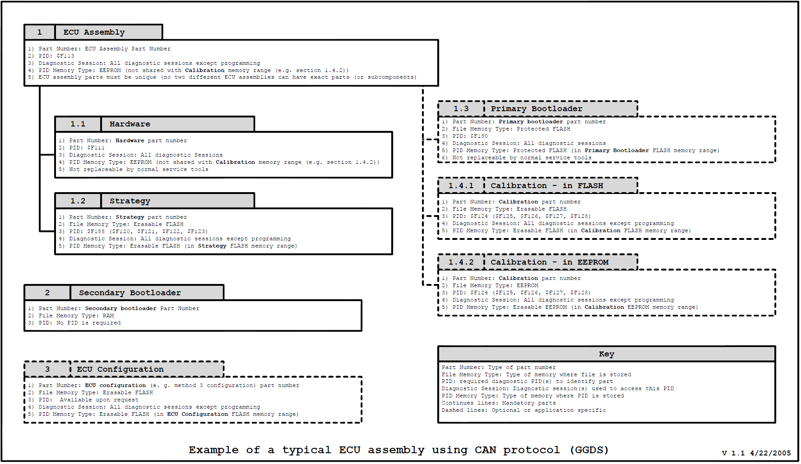

Example of a Typical ECU Assembly Using CAN Protocol (GGDS 003 & SWDL 005)
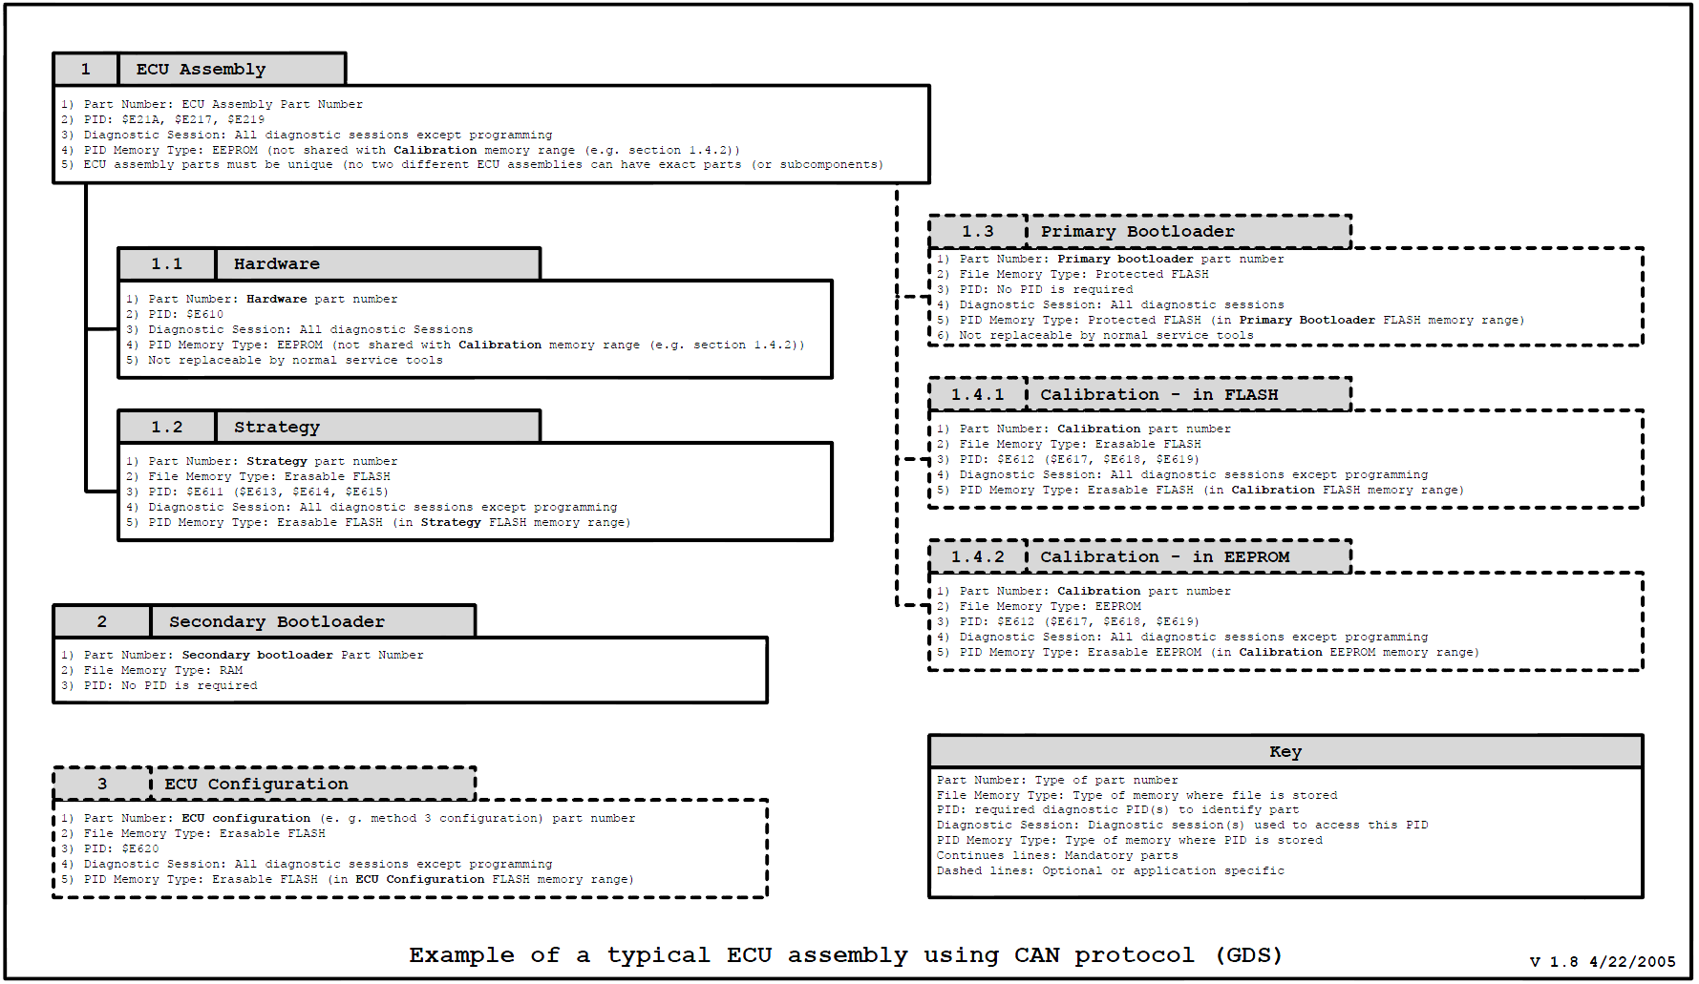

Record of Revisions
Date | Document Version | Description of Revision & Portions Revised | Revised by
10-Nov-2008 | 1.0  (2008.0) | - Initial Release | SISHAC  MLEITNER  Peer Review
26-Aug-09 | 2.0  (2009.0) | - Deletion of all GCC references  - Inclusion of question for sub-processor PID/DID and Node ID  - Inclusion of questions regarding validation of compatibility  - Inclusion of question regarding module shipment to Manufacturing  - Inclusion of question regarding manufacturing trial | KHAYDEN2
20-May-2011 | 3.0  (2010.0) | - Added question A1.1-8 regarding model year carryover  - Added question A1.6-7 regarding as-built cost to be considered in Business Case  - Added question 1-8 regarding model year carryover  - Added question 5-16 regarding direct configuration DIDs being modified between assembly part releases  - Added question 6-7 regarding as-built cost to be considered in Business Case  - Added question C1.1-8 regarding model year carryover  - Added question C1.6-7 regarding as-built cost to be considered in Business Case | KHAYDEN2
31-May-11 | 4.0  (2010.1) | - Deleted question A1.6-7 regarding as-built cost to be considered in Business Case  - Deleted question 5-16 regarding direct configuration DIDs being modified between assembly part releases  - Deleted question 6-7 regarding as-built cost to be considered in Business Case  - Deleted question C1.6-7 regarding as-built cost to be considered in Business Case  - Added question A1.2-5 regarding Configuration changes that will revise Part2 spec and As Built data  - Added question 2-8 regarding Configuration changes that will revise Part2 spec and As Built data  - Added question 2-8 regarding Configuration changes that will revise Part2 spec and As Built data  - Changed Document Administrator from mleitner to khayden2 | KHAYDEN2
06-June-11 | 5.0 | - Updated sections A0-7, A0-3, 1-7, 4-3, and C1.4-3 with IVS web address | KHAYDEN2
31-May-12 | 6.0 | - Removed redundant questions of former checklist items: A1.1-2, 1-2, and renumbered questions accordingly  - Added examples to questions via new checklist items: A1.1-3, 1-3  - Updated content regarding ECU drawings via new checklist items: A1.1-5, 1-5  - Included PID E611 and DID F188 as examples to new checklist items: A1.1-3 and 1.3  - Update to Base Part Number Report link on checklist items: A1.1-6, 1-6  - Rephrased checklist items: A1.1-7, 1-7  - Added Direct Configuration PID(s) EExx, DID(s) DExx to checklist items: A1.2-5, 2-5  - Removed redundant questions regarding configuration method of former checklist items: A1.2-1, 2-1, C1.2-1, and renumbered questions accordingly  - Added reference to MPC and SWDL requirements to questions of checklist items: A1.2-2, 2-5, and C1.2-5  - Removed redundant checklist item regarding ECU Configuration Specification: A1.2-3 deleted and merged with A1.5.1, 2- deleted and merged with 5-1, and C1.2-7 deleted merged with C1.5-1; renumbered questions accordingly  - Updated questions to included Part 1 testing details of checklist items: A1.5-1, 5-1, and C1.5-1  - Included an example of a full part lineage in checklist items: A1.3-2, 3-2, C1.3-2  - Added a NOTE to specify that IVS access are available to Ford Engineers and Suppliers in checklist items: A1.4-3, 4-3, and C1.4-3  - Rephrased questions regarding direct configuration PID/DID changes of compatible parts, and change font color from red to black: A1.2-3, 2-6, and C1.2-6  - Added link to IVS Portal to access the IVS User Guide: A1.4-3, 4-3, C1.4-3  - Deleted redundant question regarding IVS training since the question regarding access request includes User Guide reference for users to reference after completing training with IVS engineer and/or web-based training modules. Former checklist items deleted were A1.4-4, 4-4, and C1.4-4. Renumbered questions accordingly.  - Changed HEX and PID reference to VBF and DID, respectively, for questions for GGDS modules in section B.  - Added examples of component and supporting part numbers to checklist items: A1.5-12, 5-12, and C1.5-12  - Elaborated on what coordination means and added examples to checklist items: A1.5-15, 5-15, an d C1.5-15  - Deleted questions regarding service requirements per Part1 compliance testing and test verification via Service Flash Tool since these questions were redundant to checklist items regarding NetCom Test / Validation. Questions deleted were formerly numbered as A1.6-2, A1.6-3, 6-2, 6-3, C1.6-2, and C1.6-3, and remaining questions renumbered accordingly.  - Deleted questions regarding manufacturing requirements per Part1 compliance testing and test verification via Service Flash Tool since these questions were redundant to checklist items regarding NetCom Test / Validation. Questions deleted were formerly numbered as A1.7-1, A1.7-2, 7-1, 7-2, C1.7-1, and C1.7-2, and remaining questions renumbered accordingly.  - Deleted question formerly numbered C1.7-5 since it was repeated exactly in following questions and replaced it with inquiry on blank module usage. New checklist item number C1.7-3.  - Renumbered section 8 correctly  - Changed content of question from compatibility to coordination verification for checklist items: A1.8-9, 8-9, and C1.8-9 | KHAYDEN2
10/23/12 | 6.1 | 1 Added IVS engineer and SW engineer contact name in front page.  2 Modified Q: 1-3 - What Data Identifiers (DIDs) are used?  3 On Q: 4-3 - Added link to training material for getting IVS access.  4 Added Question: Do you understand what an IVS Service Action is? If so please explain briefly.  5 Added Question: Do you understand what a DID report is? If so please explain briefly.  6 Added Question: Have you received the Ford’s SW Release Notes Template? Will you be using this format or another one?  7 Added Question: Do you understand de Software Change Management Process? If so, who will be the person reporting issues to the Software Governance Board.  8 Added Question: Who will be the main contact for providing DIDs reports?  9 Modified question A1.5-15:Is the SBL released as an end item as it should?  10 Modified question Q: 1-1: A note indicating that modules released under SWDL v3.0+ are required to use a Core Assembly base part number (part number is used to identify the combination of the ECU hardware (pc circuit board micro-controller and memory, and housing (for parts with HMIs) and any non-replaceable software (bootloaders and other fixed software).) , not a Hardware base part number.  11 Modified question Q: 1-1: Added a request for Method 3 part numbers.  12 Added question: Q: 1-8 Does the header information in the hex or vbf file match the associated SW part number in WERS?  13 Appended to Question 2-5: Is the Part II Specification part fully released in WERS?  14 Added another question 5-12: What is the DID for the Part II Specification part number and which diagnostic sessions is it supporting (e.g. F110, Default Session 01, Prog Session 02, Extnd Session 03)?  15 On Q:A1.8-5 Corrected the reference to the IVS Rel. Proc. to: IVS Rel Proc v3.2 sec 5.24  16 On Q:A1.8-6 Corrected the reference to the IVS Rel. Proc. to: IVS Rel Proc v3.2 sec 19, 23, 24.1, 24.2, 24.3  17 On Q:A1.8-7 Corrected the reference to the IVS Rel. Proc. to: IVS Rel Proc v3.2 sec 6.2  18 On Q: 1-1 Corrected the reference to the IVS Rel. Proc. to: IVS Rel Proc v3.2 sec 6.2  19 On Q: 1-5 Corrected the reference to the IVS Rel. Proc. to: IVS Rel Proc v3.2 sec 5.24  20 On Q: 1-6 Corrected the reference to the IVS Rel. Proc. to: IVS Rel Proc v3.2 sec 4.3  21 On Q: 1-7 Corrected the reference to the IVS Rel. Proc. to: IVS Rel Proc v3.2 sec 4.9  22 On Q: 2-5 Corrected the reference to the IVS Rel. Proc. to: IVS Rel Proc v3.2 sec 19, 23, 24.1, 24.2, 24.3  23 On Q: 3-1 Corrected the reference to the IVS Rel. Proc. to: IVS Rel Proc v3.2 sec 18.1  24 Added question: Are you familiar with the GSWUM?  25 On Q: 6-1 Corrected the reference to the IVS Rel. Proc. to: IVS Rel Proc v3.2 sec 13.2  26 On Q: 6-4 Corrected the reference to the IVS Rel. Proc. to: IVS Rel Proc v3.2 sec 14, 24.7  27 On Q: 7-4 Corrected the reference to the IVS Rel. Proc. to: IVS Rel Proc v3.2 sec 13.2  28 On Q: 8-6 Corrected the reference to the IVS Rel. Proc. to: IVS Rel Proc v3.2 sec 19, 23, 24.1, 24.2, 24.3  29 Added the links to the GGDS and SWDL Specs: https://f1.ford.com/eRoom/EESE/NetCom/0_4906d  30 On Q: A1.1 6 made a reference to FAP03-145, section 8. In there, the Master Part Number Registry is explained as the official reference for base part numbers  31 On Q:A1-1-7, appended a question: Are you using the same version of the Operating System?  32 On Q:A1.2-2 Appended a question: Do you already have a schedule to complete the WERS releases for each milestone? If yes, how much time in advance before the milestone’s date?  33 On Q: A1.3 2 Added an explanation about the Backwards Compatibility concept.  34 For Q: A13-3, Added a request for the supplier to deliver compatibility tests results document in a matrix.  35 For Q:A1.5-2, Added a request for a flow diagram for their test plan.  36 For Q: A1.5-3, Added a request for a bus data log.  37 For Q: A1.5-15, Appended a request for the IVS/D&R representatives of the other coordinated modules.  38 For Q: A1.8-1, Added a question about the advancement of the parent assemblies.  39 Q:B1-4-6 Added a Question about how familiar is the Supplier and the D&R with the limitations report.  40 Q:B1-4-8 Added a Question about FSN ID for the Supplier.  41 Q:B1-4-7 Added a question: What controls are in place in order to ensure that no module is shipped to the plant before the software is already in IVS?  42 Removed Column for E events.  43 Changed the M1DC/PEC/CC column to “GPDS Milestone”  44 Removed empty sheet on the Appendix section. | GBRAHMSR
12/05/2012 | 7 | 1 on Q:B1:3-2 Appended a request to ensure that all assemblies from full lineages that had been released in WERS are represented in IVS to prevent trapped suffixes and End of Line alarms when vehicles contain assemblies not present in IVS.  2 Merged Sections A and B and named it Section A.  3 Removed Section C for LIN based Modules, which will be addressed in a separate document.  4 Recreated Index and changed numbers of questions to remove letters no longer necessary.
03/21/2013 | 7.1 | 1 Appended note on Question 1.1 about design changes early on the GPDS to confirm IVS support  2 Added question 2.8 on Processing Order requirements  3 Added question 2.9 on Files dependency when programming the module. | GBRAHMSR
04/03/2013 | 7.2 | 1. Added third option under In-Vehicle Software Release & Module Flash question.  2. Corrected Images resolution in Appendix | GBRAHMSR
05/20/2013 | 7.2 | Section 8 was reduced from 11 to 7 questions | GBRAHMSR
5/29/2013 | 7.3 | Deleted Questions 1.6 and 1.7.  Deleted question 2.7, 5.9, 5.10,5.12,5.14, 5.18 | GBRAHMSR/ MZEMPOAL
8/1/2013 | 7.4 | Added an incremental question about backwards compatibility.  Added question 4-10 | GBRAHMSR
Master Register: Department Master List of Q. Docs. Document Administrator: Gerardo Brahms (GBRAHMSR). Authorized by Department Manager.

